Final ( 2020-2021)
01. A. Fill in the blanks in each of the following statements: (0.5 × 8 = 4)
i) If a class declares constructors, the compiler will not create a ___ .
ii) The public methods of a class are also known as the class’s ___ .
iii) Lists and tables of values can be stored in ___ .
iv) The number used to refer to a particular array element is called the element’s ___ .
v) A variable known only within the method in which it is declared is called a ___ variable.
vi) It’s possible to have several methods with the same name that each operate on different types or numbers of arguments. This feature is called method ___ .
vii) Typically, ___ statements are used for counter-controlled repetition and ___ statements for sentinel-controlled repetition.
viii) Methods that perform common tasks and do not require objects are called methods ___ .
Sol^{n}:
i) default constructor
ii) interface
iii) arrays
iv) index
v) local
vi) overloading
vii) for, while
viii) static

01. B. Write a Java statement or a set of Java statements to accomplish each of the following tasks: (3) a) Sum the odd integers between 1 and 99, using a for statement. Assume that the integer variables sum and count have been declared. b) Print the integers from 1 to 20, using a while loop and the counter variable i. Assume that the variable i has been declared, but not initialized. Print only five integers per line. c) Repeat part (b), using a for statement.Sol^{n}:
Sol^{n}:
a) Sum the odd integers between 1 and 99:
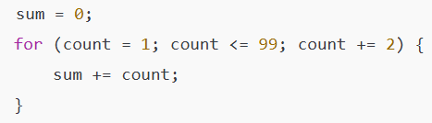
b) Print integers from 1 to 20 using while (5 per line)
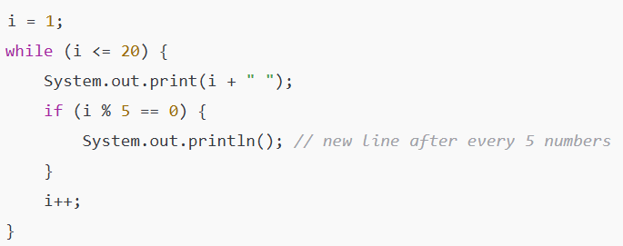
c) Repeat part (b) using for
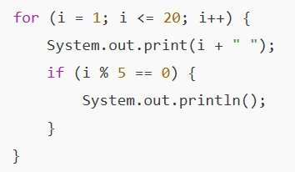

01. C.
i) What gives Java its “write once and run anywhere” nature?
ii) What happens at runtime during Java compilation?
iii) Can you save a Java source file by another name than the class name?
iv) Can you have multiple classes in a Java source file?
Sol^{n}:
i) Java’s platform independence through Java Virtual Machine (JVM) and bytecode gives it the “write once, run anywhere” nature.
ii) At runtime, the JVM loads the bytecode, and the Just-In-Time (JIT) compiler translates bytecode into machine code for execution.
iii) Yes, but if the class is declared public, the source file must have the same name as the public class.
iv) Yes, you can have multiple classes in one Java source file, but only one public class, and the file name must match that public class.

01. D. Write a Java program that declares an array of 10 integers and initializes it with values 1, 2, 3, 4, …, 10. Also count and print how many even numbers and how many odd numbers are in the array.
Sol^{n}:
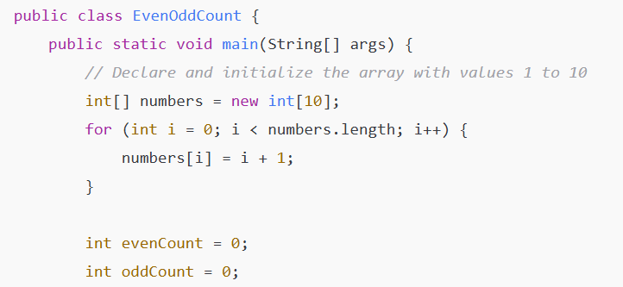
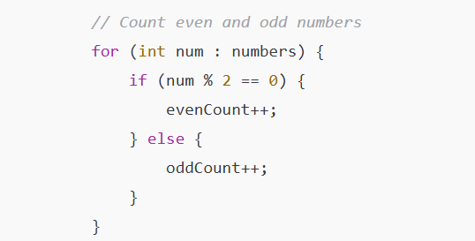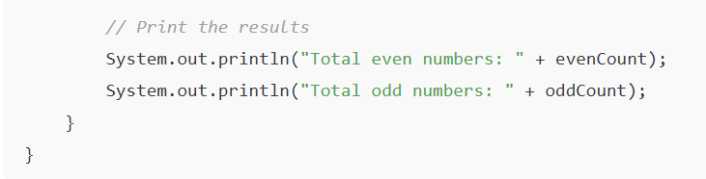

02. A. What are the various access specifiers in Java? Write an example of public access modifier. (4 marks)
Sol^{n}:
Definition:
Access modifiers in Java are keywords that set the visibility (scope of access) of classes, methods, and variables. [No need definition. It is only for knowledge gain]
Types of Access Modifiers:
- public – Accessible from anywhere.
- protected – Accessible within the same package and by subclasses.
- default (no modifier) – Accessible only within the same package.
- private – Accessible only within the same class.
Example of public access modifier:
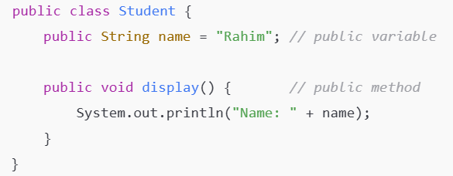

02. B. Write the rules of Constructor. What is the purpose of a default constructor? Explain with example. (4 marks)
Sol^{n}:
Rules of Constructor:
- Constructor name must be the same as the class name.
- It does not have a return type (not even void).
- It is automatically invoked when an object is created.
- It can be parameterized or default.
Purpose of Default Constructor:
- A default constructor initializes objects with default values.
- If no constructor is defined, Java automatically provides a default constructor.
Example:
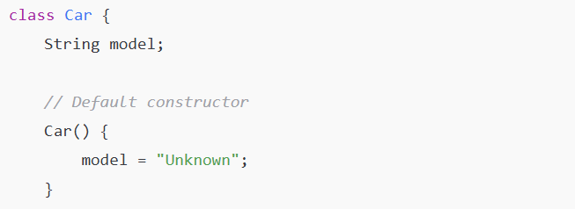
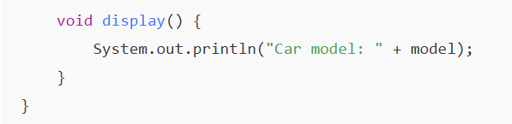
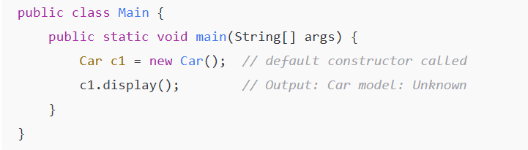

02. B. What is the output of the following Java program? (3 marks)
i)
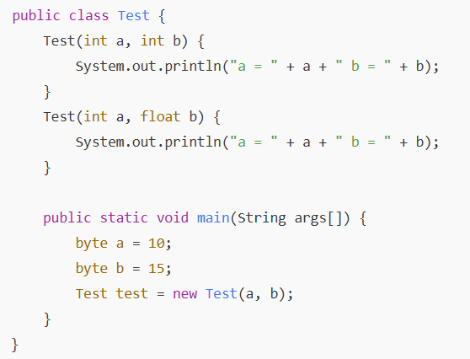
ii)
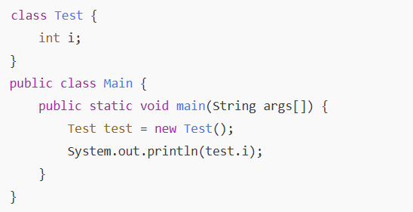
iii)
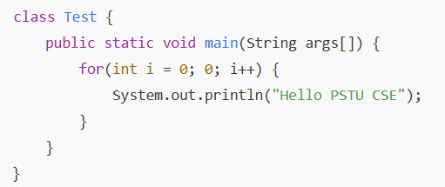
Sol^{n}:
  - a = 10 b = 15
  - 0
  - Compilation Error
Explanation: [Not question answer, gain knowledge]
- • a and b are byte, but Java promotes them to int when passed to a method/constructor.
• So it matches the constructor Test (int a, int b).
- • Instance variable i is not initialized explicitly.
• In Java, uninitialized instance variables of int type default to 0.

- • In a for loop, the middle expression must be boolean.
• Here 0 is not a boolean, so compilation error occurs.

02. D. Write a Java program to print a pyramid using star pattern. Number of rows input from keyboard. (3 marks)
Sol^{n}:
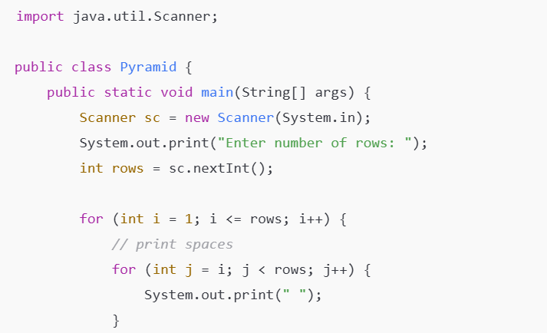
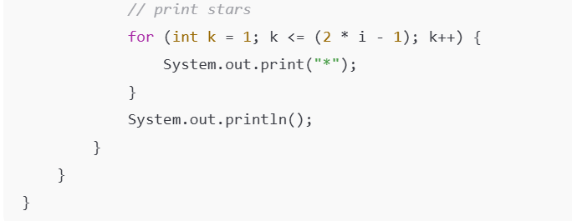
Output:
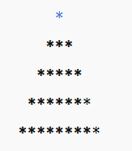

03. A. What is the static variable? Explain a java program with and without static variable.
Sol^{n}:
A static variable in Java is a variable that is declared with the static keyword and is associated with the class rather than instances. It is shared among all objects of the class and only one copy of the variable exists in memory.

Program with static variable:
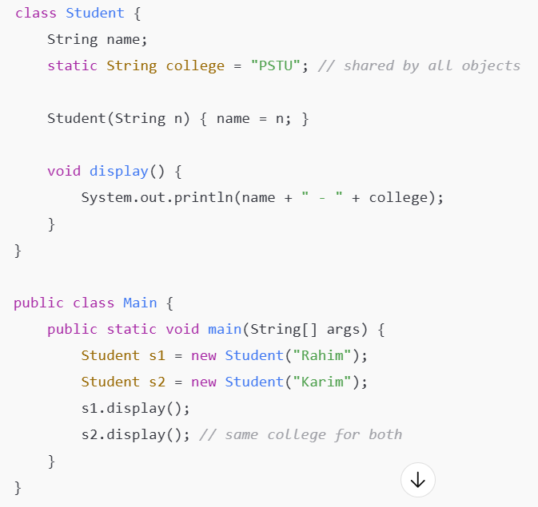
Output:
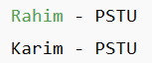
Program without static variable:
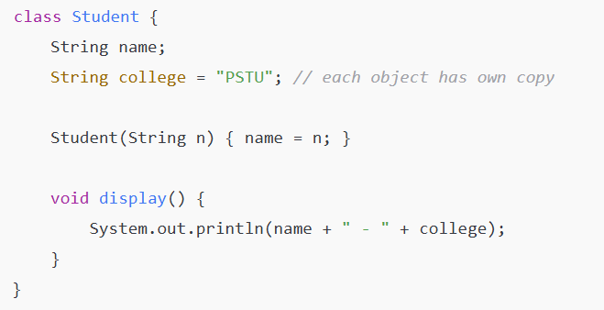
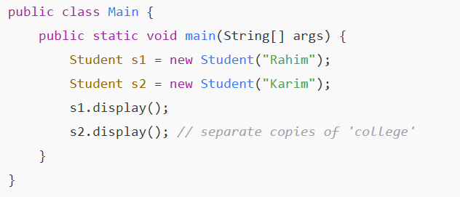
Output:
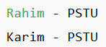

03. B. What is the difference between static (class) method and instance method? (3 marks)
Sol^{n}:
Static (Class) Method | Instance Method
Declared with the keyword static. | Declared without static.
Belongs to the class, not to objects. | Belongs to the object.
Can be called without creating an object. | Requires creating an object.
Can access only static data directly. | Can access both static and instance data.
Example: Math.sqrt(16) | Example: obj.display()

03. B. What are the main uses of this keyword? (3 marks)
Sol^{n}:
The main uses of the this keyword in Java are:
- To refer to the current class’s instance variables.
- To call the current class’s methods.
- To pass the current object as an argument to another method or constructor.

03. C. Define Object and Class. Write Object and Class Example: main outside the class and main within the class. (4 marks)
Sol^{n}:
Definition:
Class:
A class is a blueprint or template that defines the attributes (data members) and behaviors (methods) of objects.
Object:
An object is an instance of a class. It represents a real-world entity with properties and behaviors defined by its class.
Example 1: (main outside the class)
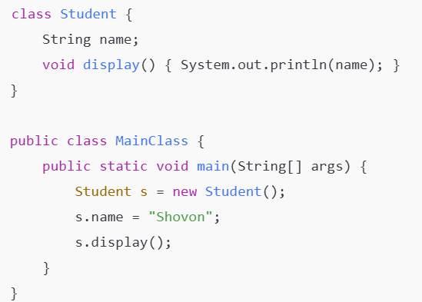

Example 2: (main within the class)
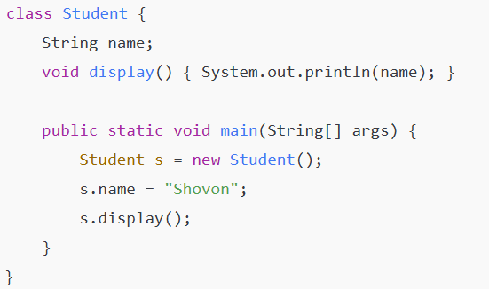

03. D. Write a Java program to sort an array of given integers using the Bubble sorting Algorithm. ( 4 marks)
Original Array: [7, -5, 3, 2, 1, 0, 45]
Sorted Array: [-5, 0, 1, 2, 3, 7, 45]
Sol^{n}:
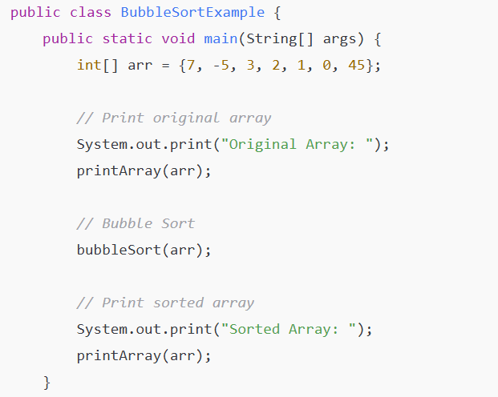
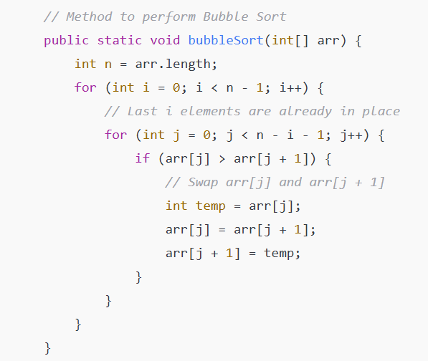
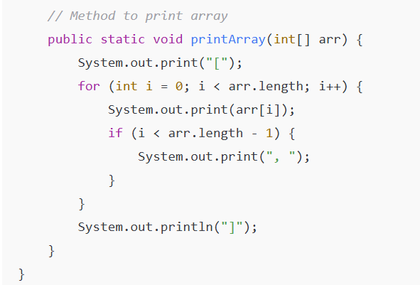

04. A. Differentiate between the throw and throws keyword. (3 marks)
Sol^{n}:
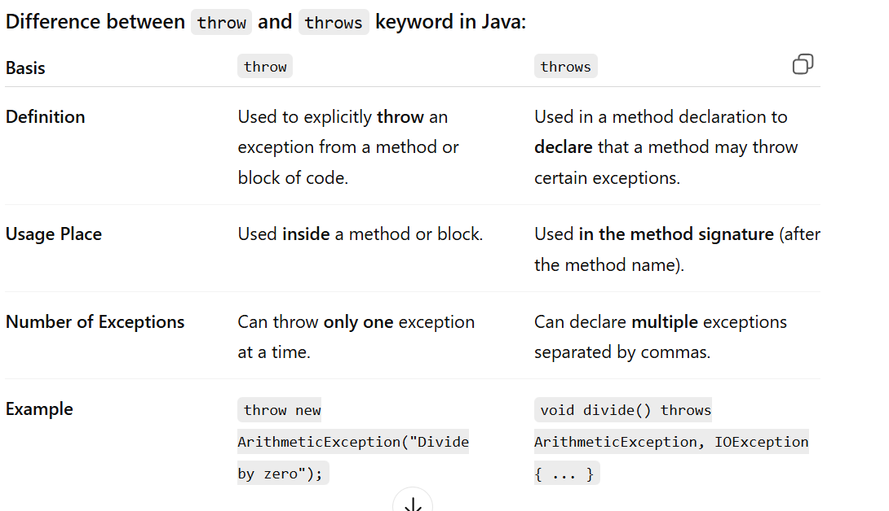

04. B. “Aggregation represents HAS-A relationship.”-explain with example. (3 marks)
Sol^{n}:
Explanation:
Aggregation is a type of association in object-oriented programming where one class “has a” reference to another class.
It represents a HAS-A relationship, meaning the lifetime of the contained object is independent of the container object.
In simple words, if the container object is destroyed, the contained object can still exist.
Example in Java:
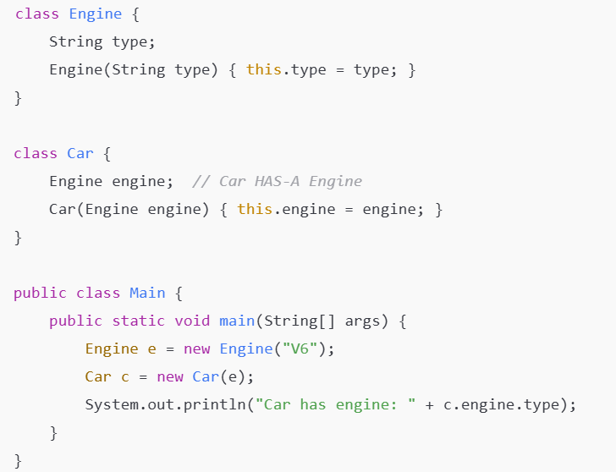

04. C. Is it possible to make any class read-only or write-only in java? How? (3 marks)
Sol^{n}:
Yes, it is possible to make a class read-only or write-only in Java by controlling access to its data members using getter and setter methods.
🔹 Read-only class:
A class is read-only if you can only read its data (no modification allowed).
Achieved by providing only getter methods (no setters).
Example:
1  2  3  4  5  6  7  8 | class Student {  private String name = "Sakib";  // Only getter method  public String getName() {  return name;  }  }

➡ Here, the value of name can be read but cannot be changed.
🔹 Write-only class:
A class is write-only if you can set data but not read it.
Achieved by providing only setter methods (no getters).
Example:
1  2  3  4  5  6  7  8 | class Student {  private String name;  // Only setter method  public void setName(String name) {  this.name = name;  }  }

➡ Here, you can assign a value to name but cannot read it from outside the class.

04. D. What is the use of instance initializer block while we can directly assign a value in instance data member? (3 marks)
Sol^{n}:
An Instance Initializer Block (IIB) in Java is used to initialize instance variables when creating an object — similar to assigning values directly, but it offers extra flexibility.
🔹 Main Uses:
- To perform complex initialization
→ When initialization requires logic (like loops, condition checks, or try-catch), which can’t be done with direct assignment.
- To share common code among multiple constructors
→ If several constructors have the same initialization code, you can put it in the IIB instead of repeating it.
- To initialize instance variables before the constructor executes
→ IIB runs before the constructor every time an object is created.
1  2  3  4  5  6  7  8  9  10  11  12  13  14  15 | class Student {  int id;  String name;  // Instance Initializer Block  {  id = 101;  name = "Sakib";  System.out.println("Instance block executed");  }  Student() {  System.out.println("Constructor called");  }  }

04. E. How can you achieve abstraction in java? [2 marks]
Sol^{n}:
In Java, abstraction can be achieved in two ways:
Using Abstract Classes –
Declare a class as abstract and include abstract methods (methods without a body).
1  2  3  4  5  6  7  8 | 1. abstract class Animal {  2. abstract void sound(); // abstract method  3. }  4.  5. class Dog extends Animal {  6. void sound() {  7. System.out.println("Bark");  8. }

Using Interfaces –
Define an interface with abstract methods that must be implemented by classes.
1  2  3  4  5  6  7  8  9 | 1. interface Animal {  2. void sound();  3. }  4.  5. class Dog implements Animal {  6. public void sound() {  7. System.out.println("Bark");  8. }  }

05. A. Write a java program for demonstrating several thread states. [4 marks]
Sol^{n}:
Here’s a simple Java program to demonstrate several thread states such as New, Runnable, Timed Waiting, and Terminated.
1  2  3  4  5  6  7  8  9  10  11  12  13  14  15  16  17  18  19  20  21  22  23  24  25  26  27 | class MyThread extends Thread {  public void run() {  try {  System.out.println("Thread running...");  Thread.sleep(500); // TIMED_WAITING  System.out.println("Thread finished.");  } catch (InterruptedException e) {  System.out.println(e);  }  }  }  public class ThreadStatesDemo {  public static void main(String[] args) throws Exception {  MyThread t = new MyThread(); // NEW  System.out.println("State after creation: " + t.getState());  t.start(); // RUNNABLE  System.out.println("State after start(): " + t.getState());  Thread.sleep(200);  System.out.println("State while sleeping: " + t.getState());  t.join();  System.out.println("State after completion: " + t.getState()); // TERMINATED  }  }

05. B. "Java doesn't allow the return type-based overloading, but JVM always allows return type-based overloading."-justify the statement with example. (4 marks)
Sol^{n}:
In Java, method overloading is based on the method name and parameter list, not on the return type.
If two methods have the same name and parameters but different return types, the Java compiler will throw an error.
This is because the compiler uses only the method name and parameters to identify methods — return type is not part of the method signature.
However, at the JVM (Java Virtual Machine) level, methods are internally identified using the name + parameter types + return type.
So, JVM technically supports return type-based overloading, but the Java language syntax does not allow it to avoid ambiguity and confusion at compile time.
Example:
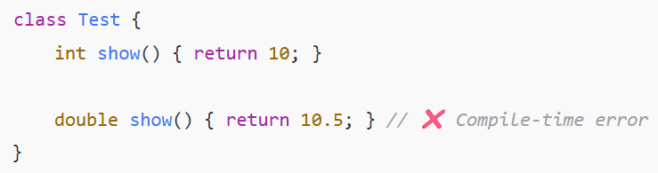
Error:
method show() is already defined in class Test
Justification:
- Java compiler does not include return type in the method signature.
- JVM can technically distinguish methods by return type, but Java syntax forbids it.
- Therefore, return type-based overloading is possible in JVM, but not allowed in Java source code.

05. C. Multiple inheritances is not supported through class in java, but it is possible by an interface, why? (3 marks)
Sol^{n}:
In Java, multiple inheritance through classes is not allowed because if a class inherits from two classes having the same method, it creates ambiguity known as the Diamond Problem. The compiler cannot decide which method to use, leading to errors.
However, multiple inheritance through interfaces is allowed because interfaces only declare methods without implementing them (except default/static methods). The implementing class provides the actual method body, so there is no ambiguity.

05. D. Can we initialize blank final variable? How? (3 marks)
Sol^{n}:
Yes, we can initialize a blank final variable, but it must be initialized exactly once before the constructor ends (for instance variables) or in a static block (for static variables).
Explanation: (How)
A blank final variable is a final variable declared without an initial value.
If a blank final variable is not assigned a value before the object is fully constructed, the compiler will give an error.

06. A. What will be the output of the following Java programs?
[4 marks]
i)
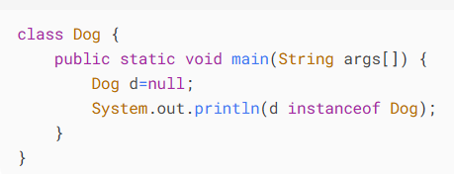
ii)
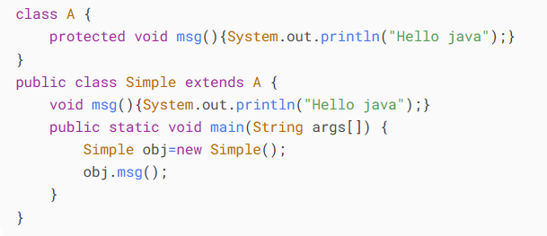
iii)
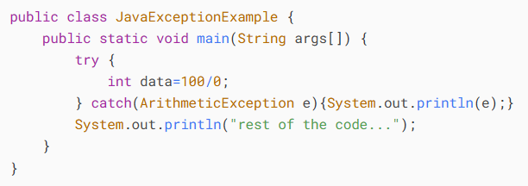

iv)
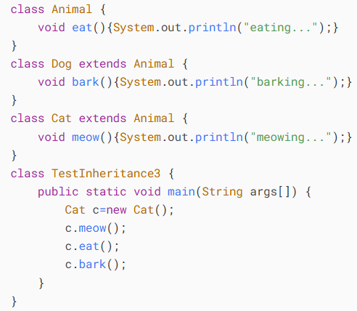
Sol^{n}:
- false
- Compilation Error
- java.lang.ArithmeticException: / by zero
rest of the code...
- Compilation Error
Explation:
- • d is null.
• The instanceof operator returns false if the reference is null.
- • In class Simple, msg() overrides A.msg() but with default access, which is weaker than protected.
• Java does not allow weakening access while overriding.
• So this code will not compile.
- • 100/0 throws ArithmeticException.
• The exception is caught and printed.
• Then the program continues.
- • c is of type Cat.
• Cat has meow() and inherits eat().
• bark() is not defined in Cat → this is a compile-time error.

06. B. How to access package from another package? [2 marks]
Sol^{n}:
To access a class from another package in Java, you need to:
- Import the package/class using the import statement.
- Use the fully qualified name if you don’t import.
Example 1: Using import
Suppose Student is in package com.java.point:
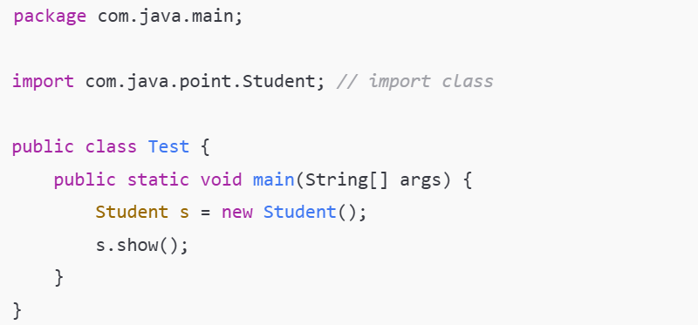
Example 2: Using fully qualified name
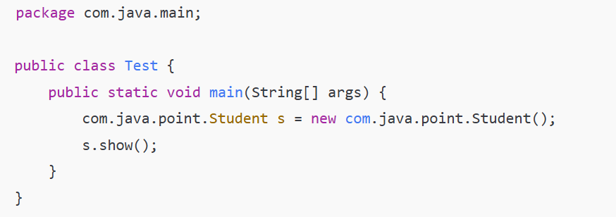

06. C. What is the purpose of join method? [2 marks]
Sol^{n}:
To make one thread wait for another thread to finish before continuing its own execution.
1  2  3  4  5  6  7  8  9  10  11  12  13  14  15 | class MyThread extends Thread {  public void run() {  for (int i = 1; i <= 3; i++) {  System.out.println(i);  }  }  public static void main(String[] args) throws InterruptedException {  MyThread t1 = new MyThread();  t1.start();  t1.join(); // main thread waits until t1 finishes  System.out.println("Main thread ends after t1 finishes");  }  }

06. D. How to perform two tasks by two threads? [2 marks]
Sol^{n}:
You can perform two tasks by two threads in Java by creating two Thread objects, each executing its own task.
1  2  3  4  5  6  7  8  9  10  11  12  13  14  15  16  17  18  19  20  21 | class Task1 implements Runnable {  public void run() {  System.out.println("Task 1 is running");  }  }  class Task2 implements Runnable {  public void run() {  System.out.println("Task 2 is running");  }  }  public class Test {  public static void main(String[] args) {  Thread t1 = new Thread(new Task1());  Thread t2 = new Thread(new Task2());  t1.start(); // starts Task 1  t2.start(); // starts Task 2  }  }

06. E. What is the Thread Scheduler and what is the difference between preemptive scheduling and time slicing? [4 marks]
Sol^{n}:
1. Thread Scheduler:
The Thread Scheduler is part of the JVM that decides which thread to run and when.
- It manages thread execution based on thread priorities.
- It does not guarantee exact order, but higher-priority threads usually get more CPU time.
2. Difference between Preemptive Scheduling and Time Slicing:
Basis | Preemptive Scheduling | Time Slicing (Round-Robin)
Definition | The CPU is allocated to the highest priority thread. Lower priority threads wait until the higher one finishes. | CPU time is divided into equal slices, and threads are executed in round-robin fashion.
Context Switch | Occurs only if a higher-priority thread arrives. | Occurs after each time slice expires.
Thread Priority | Important; higher priority threads dominate. | Less important; all threads get equal CPU time in their turn.
Example | Java Thread Scheduler in Windows may use preemptive scheduling. | Many JVMs use time slicing for fairness.

